Assignment-1
Name: Pippariwar Anvesh Sai
Email: pippariwaranveshsai@gmail.com
1️⃣ Number Classification (if + function)
Write a shell script that uses a function to check whether a number is positive, negative, or zero using if.
read -p "Enter a number: " n

Code
check_number() {
if [ $1 -gt 0 ]; then
echo "$1 is Positive"
elif [ $1 -lt 0 ]; then
echo "$1 is Negative"
else
echo "Number is Zero"
fi
}
check_number $n
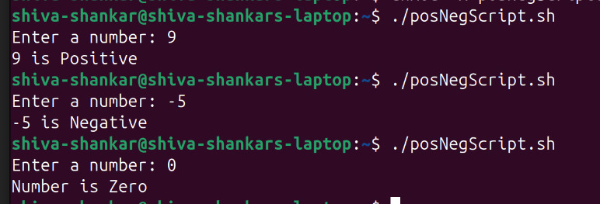
2️⃣ Factorial of a Number (while + function)
Write a shell script to calculate the factorial of a number using a while loop inside a function.
read -p "Enter a number: " n

factorial() {
fact=1
i=1
while [ $i -le $1 ]
do
fact=$((fact * i))
i=$((i + 1))
done
echo "Factorial = $fact"
}
factorial $n
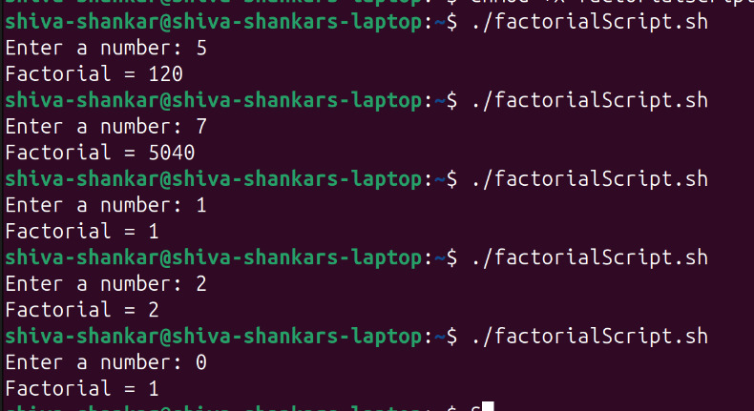

3️⃣ Sum of N Numbers (for + function
Write a shell script to calculate the sum of numbers from 1 to N using a for loop inside a function.
read -p "Enter N value: " n
sum_numbers() {
sum=0
for ((i=1; i<= $1; i++))
do
sum=$((sum + i))
done
echo "Sum = $sum"
}
sum_numbers $n
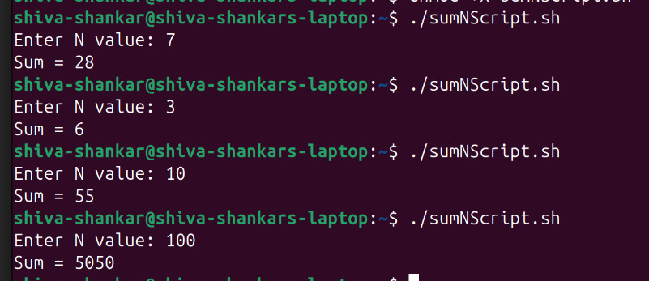
4️⃣ Prime Number Check (if + for + function)
Write a shell script that uses a function to check whether a given number is prime using if and for.
read -p "Enter a number: " n
check_prime() {
if [ $1 -le 1 ]; then
echo "$1 is not Prime"
return
fi
for ((i=2; i<= $1/2; i++))
do
if [ $(( $1 % i )) -eq 0 ]; then
echo "$1 is not Prime"
return
fi
done
echo "$1 is Prime"
}
check_prime $n
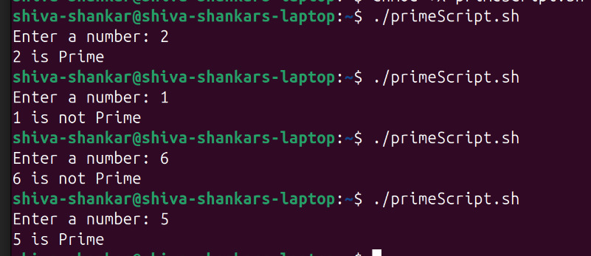
5️⃣ Reverse a Number (while + if)
Write a shell script to reverse a number using a while loop and if conditions where required.
read -p "Enter a number: " n
rev=0
while [ $n -gt 0 ]
do
rem=$((n % 10))
rev=$((rev * 10 + rem))
n=$((n / 10))
done
echo "Reversed number = $rev"
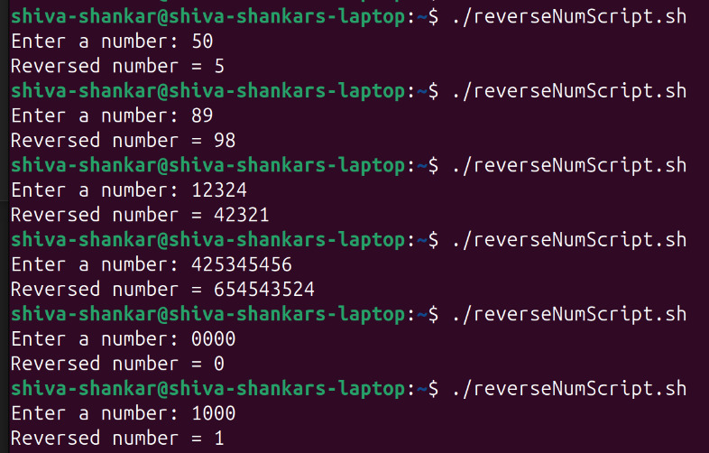

6️⃣ File Existence & Permission Check (if + function)
Write a shell script that uses a function to check if a file exists and whether it has read, write, and execute permissions.
read -p "Enter file name: " file
file_check() {
if [ -f "$1" ]; then
echo "File exists"
[ -r "$1" ] && echo "Read permission: Yes" || echo "Read permission: No"
[ -w "$1" ] && echo "Write permission: Yes" || echo "Write permission: No"
[ -x "$1" ] && echo "Execute permission: Yes" || echo "Execute permission: No"
else
echo "File does not exist"
fi
}
file_check $file
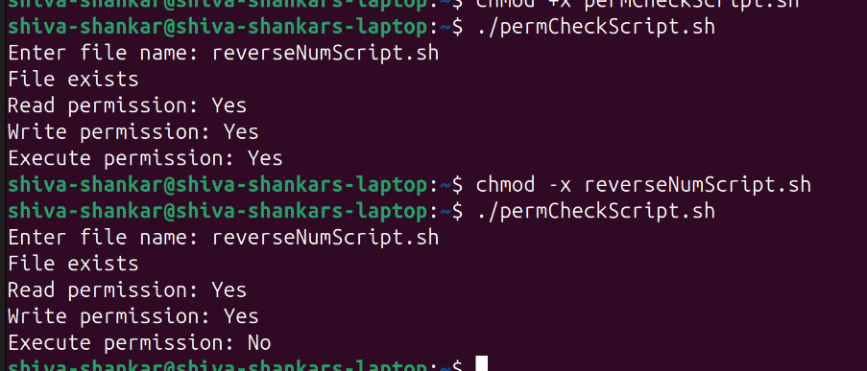
7️⃣ Menu-Driven Calculator (while + case + function)
Write a shell script that shows a menu in a while loop and performs add, subtract, multiply, divide using functions.
add() {
echo "Result = $(( $1 + $2 ))"
}
sub() {
echo "Result = $(( $1 - $2 ))"
}
mul() {
echo "Result = $(( $1 * $2 ))"
}
div() {
echo "Result = $(( $1 / $2 ))"
}
while true
do
echo "----- Calculator Menu -----"
echo "1. Addition"
echo "2. Subtraction"
echo "3. Multiplication"
echo "4. Division"
echo "5. Exit"

read -p "Enter your choice: " choice

case $choice in
1)
read -p "Enter two numbers: " a b
add $a ;;
2)
read -p "Enter two numbers: " a b
sub $a $b
;;
3)
read -p "Enter two numbers: " a b
mul $a $b
;;
4)
read -p "Enter two numbers: " a b
div $a $b
;;
5)
echo "Exiting Calculator"
exit
;;
*)
echo "Invalid choice"
;;
esac
done

